**The Discovery of a Magic Handbook Prior to Chinese OBI:**

**An evidence of an Earliest Syncretism of Shamanism with predicted-Christianity in China**

**Abstract**The Chinese Numeral, heavenly-Stems, earthly-Branches and the sexagenary Cycle are consistently used throughout the history in its civilization. However, seldomly did people study them as one integrated organic system. For the first time, based upon large amount of evidence, this paper proposed that the four systems indeed was the earliest pre-defined magic Handbook (distinguishing the common handbook with the capital) that existed before the OBI practice. From a shamanism perspective, the paper suggested that, being inspired from a spiritual world through their religious exercises, the Handbook was invented by a group of shamans without undergoing long time evolutionary process. To support the idea, the paper applied the contextualization methods to demonstrate a large amount of evidence to conclude that: the Handbook is an oracle akin to stories of Jesus in the Gospels. Although the eastern Magi (Mat 2:1-9) cannot be proved to be Chinese so far, they can support each other about the existence of global shamanism, underscore the Zhang’s ancient Chinese shamanism theory – the origin of ancient Chinese culture is based upon neither the pure atheism nor the theism but the syncretism of shamanism with predicted Christianity.

TOC

1. Introduction
2. The Evidence of the Existence of the Handbook
3. The Contextualization of the Handbook
4. Numeral: Genesis oriented.
5. Stems: The Cross oriented.
6. Branches: The Son oriented.
7. Sexagenary: Jesus oriented.
8. The Shamanism Perspective to the Handbook
9. Conclusion

**I. Introduction**

**The Argument about the Existence of Books at Anyang**  
 Many scholars believe that, besides of OBI (Oracle Bones Inscription) used for the religious ritual in Anyang, there must have other forms of writings for ordinary human communication, like silk documents, bamboo books, stone inscriptions, etc. The reasons are:

1. Any advanced civilization always goes with its matured language. The unearthed materials (Chorits, bronzes, grand palaces, etc.) shows that Anyang was a highly advanced society that required both centralized management cooperation and the broadly distributed social divisions. Without the efficient human communication, the whole system would not work. These suggested that the writings as a basic communication medium across space and time remain traced everywhere in Anyang. The writing language is one of the important features of any civilization.
2. Guo Morou found some records in Chinese classic documents stating that ancient people at Anyang possessed handbooks and dictionaries. (尚书·周书·多士：惟尔知，惟殷先人有册有典) [1] It implies that there were a lot of books in Anyang at that time.
3. The characters in OBI, handbook (Ce 冊 ), dictionary or law (Dian 典), brush pen (聿筆笔), draw or writing (Hua (畫, 画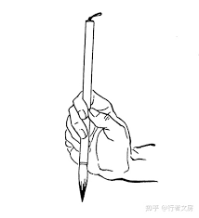 ), history (Shi史), etc. demonstrated that people at Anyang had ever involved activities of writing with brush pen and compiling of historical books[2]. The discovery of some inked scripts among OBI seems supporting this idea.[3]

However, the unearthed materials and all published archeological reports shows that the imagined ancient bamboo books, cloth documents, brush pens or other related writing materials does not exist except the OBI in Anyang. The hard evidence disappointed not only scholars but also discouraged the archeologists’ enthusiasm. Some scholars attributed it to the corruption of the materials due to several millenniums time. However, the cases, like the discovery of wheat more than three millenniums ago in China,[4] the unearthed wood chariots at Anyang, etc. made the issue more complicated and controversial.

**Discovery of the Magic Handbook Before Chinese OBI Times**

The Chinese writing devolution and depreciation process in history shows that Chinese characters were originally sacred text associated with expansive writing materials. Therefore other forms of documents cheaper than OBI did not exist at Anyang in Shang time.[5] Instead of seeking the inexpensive books in the underground, this paper insisted on looking for the books inside OBI. Through review and systematic analysis of large amount of pieces of OBI, the paper pointed out that the two pictograms ( :册 Ce, Handbook, and :典 Dian, dictionary or law) refer to the same book that contains four parts called: the Chinese numeral system, heavenly-stem(天干), earthly-branch(地支) and the sexagenary cycle. This paper will call the four-part book “Handbook” with a capital letter to distinct itself from the common handbook.

In addition to the evidence supporting to the discovery of the Handbook, the paper also explored the origin and its roles of the Handbook both in OBI study and overall Chinese culture. For the first time, the paper pointed out that the Handbook was not only a predefined manual for OBI writing practice, but also an earliest law predefined for its offspring in its culture. This discovery restored the original meaning and purpose for the longtime used Chinese characters Ce册 and Dian典.

Throughout the history, the Chinese numeral system, heavenly-stem(天干), earthly-branch(地支) and the sexagenary cycle are well-known and persistently used until today, thoughts origin and purpose were completely lost. However, it was until after East Han dynasty (25-220 AD) when people began to pay attention and gave them the term heavenly-stem (天干) and earthly-branch(地支)[6]. It was until after 1919 under the influence of the Western when people began to question its origin. E.g., Guo Morou (郭沫若) reinterpreted the meaning of each character in the stem and branch based on his belief that earthly-branch came from ancient Babylonian. But his ideas are not fully accepted since the motivation of the ancestors’ creation was still unclear. Some criticize that his explanation is subjective and filled with pan Babylonianism though his ideas are creative.[7]

A common mistake of the study is that people tend to emphasizes on the complicated stem-branch but overlook the more important but simpler numeral system. Obviously, the sexagenary cycle is created on the base of the stem and branch. But little of people recognize that stem and branch are based upon the numeral system; the four parts are integrated one organic system. As the numeral system is relatively more intuitive than others, understanding the origin and purpose of the numeral is a key to decode stem and branch and sexagenary.

Another common mistake is that people ignore the fact that the four integrated parts acted as a primary law in Chinese history. Although the law was applied differently in different period in history—the sexagenary is used for day counting during Shang and for year after Han (201 AD), the law is associated to astrology. Although the law is applied for the calendar and time (year, month, day or hour) rather for the human beings, it is greatly reverenced and strictly followed. The dogma of the absolute sacredness lead to the shamanism analysis -- the study of the OBI can become the study of the shamanism.

**The Significance of the Discovery of the Magic Handbook.**

The Handbook is a mystic religious law, greatly reverenced and acted upon in China but was ignored as the dogma of the absolute sacredness of its culture from the beginning of the Chinese writing system, the symbols of which used for calendar(甲子年、甲子月、甲子日，甲子时), the expression of which actually permeated into the soul of its people.

It was not until after the May-Fourth movement in 1919, for the first time in history, when Lu Xun and many scholars broke out an astonishingly yelling, “Perish the Chinese if not the characters die.” (汉字不灭，中华必亡). What they referred to is essentially the shamanic ghost where the Chinese writings came from. Unfortunately, soon they perished and buried into the tomb of the Chinese characters. In a national meeting in March of 2022, the Chinese representatives began to discuss if the English class should be removed from schools in China.

The original purpose to learn Chinese characters is to become the shamanist to gain the life power through religious ritual practices. Those who fell in love with Chinese writings are indeed more or less possessed by a shamanic demon.

From a perspective of the cultural structures, the Handbook is not only the core of the OBI, the earliest law and the first reliable book in China, but also the origin of Chinese writing, the backbone of Chinese culture. To study the Handbook is to dismantle the gained magic power. To unveil the essence of the Handbook in pubic is equivalent to bruise the head of the dragon.

turn. There is a weird and mystic religious law, greatly reverenced and acted upon in the Greek, half-forgotten in the Roman Catholic, and absolutely extinct in the Protestant Church. It dates from the earliest days of Christianity and has its basis in the law just stated, of which it was a symbol and an expression. This is the dogma of the absolute sacredness of the relation between the god-parents who stand sponsors for a child.

Blavatsky, H. P. (Helena Petrovna). Studies in Occultism; A Series of Reprints from the Writings of H. P. Blavatsky No. 1: Practical Occultism—Occultism versus the Occult Arts—The Blessings of Publicity . Kindle Edition.

**II. The Evidence of the Pre-existence of the Handbook**   
 1. **Logical Evidence**   
 For those who know that one pictogram is worth one thousand words, it is not hard for them to understand that the four predefined rules (the numeral system, heavenly-stem, earthly-branch and sexagenary cycle) with 31 distinct characters and total of 92 characters is the most succinct and complicated book in China history.

First, the four parts are corelated and integrated unit. The numeral system is the beginning and the base for the stem and branch. Further, the stem and branch is the base for sexagenary cycle. More relationship will be discussed later in the paper.

Second, the Handbook plays the role of the standard references. All characters in the Handbook are among the top 200 most frequently used word. Its total usage frequency rate is far greater than any other word in OBI. In average, nearly every piece of scripture bone is linked to the Handbook. The high frequency rate shows the importance of the Handbook in OBI practice.

Moreover, in the Chinese Union Version (CUV) published in 1919, the earthly-branches are used as standard references to record the hours of the last day of Jesus.

Thirdly, the high frequent rate and consistent usage of the Handbook in OBI demonstrates that the Handbook preexist prior to OBI. The Handbook is not developed based on the OBI practice. On the country, OBI is developed based on the pre-defined magic Handbook. The Handbook is earlier than OBI, it is the origin of OBI and the backbone of the Chinese civilization.

The characters in the Handbook are among the easiest ones to be recognized in early stage. However, to overlook the existence of the Handbook is a serious mistake in OBI study.

2. **Physical Evidence**  
 Repeated duplication is one of features for any handbook. Among 50 thousand pieces of scripture bones, more than thirty pieces of bones are for the Handbook and collected in the book (JiaGuWenHeJI). This phenomenon is unique and no other duplicated scripture like this can be found in OBI. Among those, the bone (HJ 37986) contains the full 60 symbols of sexagenary cycle, which provides a solid evidence for the pre-existence of the magic Handbook.

Adam Smith suggested that these duplicated pieces of OBI were not used for divination but for scribal training.[8] Through comparison analysis, Adam found a few divergence among various duplicated pieces of OBI. Adam believes it was the evidence that errors or mistake made by the trainees.[9] Such phenomenon is unique in OBI. Obviously, the model inscriptions have two purposes: one is for trainee to mimic and practice; another is used as a manual for references to prevent from forgetting or mistakes.

The numeral system, stems and branch are not found dependently same as the sexagenary does. However, this cannot deny the pre-existence of the Handbook due to their organic integrated relationship. As compared with sexagenary, they are much easy to remember in heart.

**3.The Naming Evidence.**   
 The existence of pictograms () in OBI referring to the Handbook is another important evidence for the pre-existence of the Handbook.[10] According to the normal naming process, its name was given after the Handbook was born.

Through Chinese etymology, pictograms () can be identified as Chinese Ce (simplified 册, traditional 冊), which means “handbook, booklet, pamphlet, brochure, leaflet, handout, handbill” for today.

The pictograms Ce () is composed of two fundamental elements: the oval circle that inherits from the 4th stem represents the nailed turtle, the vertical line from the 10th of numeral that refers to the principle. The four vertical bars refer to the four pre-defined principles (numeral, heavenly-stems, earthly-branches and sexagenary circle). The four vertical lines and the 4th nail in stem testify to each other to specify the unshakable authority of the sacred law from heaven but written on turtle shells on earth. [11]

The pictograms Dian() is not something new but the pictogram Ce () associated with two praying hands that enhance the sense of divinity and authority. The Dian is still in use for today, and means “rule; law; institution; principle; dictionary;” different from a common booklet without the power.

Similarly, there is another pictogram (), the frequency of which is much higher than Dian(). However since it is lost for today, no simplified character can match it. For restoration, it can be interpreted in English as “command; order;” since the pictogram presents the law from the divine mouth. This pictogram shed the light where the Handbook came from.

There are total about thirty pictograms in OBI related to booklet Ce (). The different features carrying on the same booklet () are not contradict but compliment to each other, which demonstrates that the named booklet () is not a common book but the magic one full of divinity, authority and power.

From the perspective of the contextualization, there are many evidence and signs showing that Ce () not only refers to the Handbook prior to OBI, but also point to the advent Gospels in the NT. The relationship between the Handbook and the Gospels will be discussed later. The bottom line is that Ce () is a name or symbol specifically referring to a special booklet that has four parts in it.

The paper will use capital ‘Handbook’ to refer to the four integrated system (the numeral, heavenly-stem, earthly-branch and sexagenary). This is because the word ‘handbook’ has same meaning with Chinese character Ce (,册, booklet) while its form (handbook = hand + book) is close to Dian (, 典, law) in morphology.

Common Misleading

1. It is a misleading to viewCe as a collection of bamboo strips as in Spring Autumn and War States (600 -201 BC) represents a bamboo book. If it were, there would have at least as many of bamboo strips as the number of character Ce in OBI at that times. The fact is that no bamboo strips or any paper books are found in Anyang at OBI times.
2. It is a misleading to think (聿筆笔) as brush pen, Hua(畫,画 ) as ‘draw’, Shi史as ‘history.’  
     
   Chinese etymology shows that OBI does not have characters for traditional characters 毛(mao, brush, hair), 聿, 筆, 笔(bi, pen), 書,书 (shu, book). These words were born after 500 BC.   
     
   In the OBI, there is no sufficient evidence to show the pictogramsrelated to writing .

Even though brush character are found on oracle bones, this does not mean that a bamboo or wooden books were used. In OBI, hand represents infer the nailed hand of Jesus, inherited from the symbol of cross.

**III. The Contextualization of the Handbook of OBI**

Conclusion: The Theme of the Handbook of OBI: Gospel Oriented Code

**Numeral System: The Genesis Oriented.**

The Chinese numeral system are widely used throughout its history but did not have a name until a sealed character Shu (, 数) was created after 221 BC. From its pictogram, it can be seen that its originally meaning is related to the “woman, womb, cross and sovereign stuff” implying “fate, future” rather than math “counting” for today.  
 Compared with other oldest system, Chinese numeral system is the only one started with horizontal bar, separating the square writing space into bottom and top two parts, which is consistent to the creation account to create earth and heaven by separating water under expanse and above expanse (Gen1:7 NIV).

The sixth icon in the numeral system is visually an empty house, which can be interpreted that the numeral system is about something that has room prepared for the future. The binding of its order position with the meaningful picture makes a sense that man would be placed in the house on the sixth day after man was created, which is consistent to the creation story of Genesis on the sixth day. While Jewish kept the same story in a traditional way by gathering together in their synagogue every Saturday. From a large amount of usage in OBI, it can be found that the house plays a role equivalent to the church for today.

Among the ten sequential pictograms in the numeral system, the seventh pictogram (+,cross) is the most religious sensitive. Its index value ‘seven’ can be easily linked to the seventh day of the creation (Gen2:2-3), and Jewish Sabbath--the seventh day of the week observed from Friday evening to Saturday evening as a day of rest and blessed worship, and Sunday observed among Christians as a day of worship and celebration of resurrection of Jesus on the cross. Among all writings in the world, it is the only word that connotes three into one: 1) the religious symbol, 2) the religious meanings for both the OT and NT, 3) the physical shape of capital execution device in ancient Roman.

In the Bible (NIV), the ‘seven’ or ‘seventh’ are used 522 times (‘seven’ x502, ‘seventh’ x119 , 54 times in the book of Revelation alone). For example, the seven harvest and famine years in Pharaoh’s dreams, the seven bowls, seven trumpets, etc. in the Revelation. Many studied have been made and concluded that the number ‘seven’ in the Scripture represents completeness—physical and divine perfection. After all, the book of Genesis (Genesis 1; 2:1-2) states that God completed His perfect creation, the world, on the sixth day and rested on the seventh day.

From the hindsight of the numeral system, ‘seven’ refers to Jesus, simply because ‘seven’ is ‘cross’ and the ‘cross’ refers to Jesus. No other book can give such succinct solution as the Handbook in the world.

In Chinese writings, the seven is identical to the cross symbol, the cross infer to Jesus. Theologically, all stories or statements related to numeral seven essentially are about Jesus Christ. The numeral system is not designed for computation but for religious purpose, the will of God.   
 kjv: seven 365, seventh 117, sevenfold:5, seventy 59, = tot:562

Niv: seven 502, seventh 119 , sevenfold 1, seventy 68, Revelation: seven 35, seventh 5.

It is clear that in the Handbook, the meaning of each pictogram is determined by both its visual recognition effect and its sequential index value. There is no difference between the cardinal, ordinal or nominal numbers. The numeral system is not merely created for counting or computation but mainly for the religious purpose to convey the oracle of God-- the cross, the son, the church and the final judgement. Also it also predefined a rule for users on how to create the oracle characters. If the order is changed, all information would be changed.

However, during the bronze period after OBI was over, the position of the cross symbol in numeral system was moved to the tenth position. Such modification broke its relationship with the Genesis account, destroyed the biblical theme of the numeral system, and downgraded the role of the oracle for the Handbook as well as the sacredness of the writing system.

Unfortunately, we have to conclude that Darby’s teachings on the **rapture** and tribulation are not supported by the Bible. I

Some may focus on the news of the day in order to discern the “**signs of the times**” and predict when Jesus will return, ignoring Jesus’ teaching that *“...no one knows, not even the angels of heaven, nor the Son, but the Father only”* (Matthew 24:36).

<http://34.227.20.213/wdaws/bb/np/mySignIn.htm?ip=http://34.227.20.213:7778>

http://34.227.20.213/wdaws/bb/np/BibleStudyNotePad.htm?ip=http://34.227.20.213:7778&SSID=Yml0YnVja2V0Lm9yZy93ZGluZ3NvZnQvcHViX3dkMDE=

The first five numeral system follows the Synchronic Regularities that describe features that are common to all system, without reference to the time dimension. Axioms: A1.) All numeral notation system can represent natural numbers. A2.) All numerical notation system have a base. A3.) All numerical notation use visual and primarily non-phonetic representation. A4) All numerical notation systems are structured both intra-exponentially and inter-exponentially.[12]

**Heavenly-Stems: The Cross oriented.**

The first item in the stem is identical to the seventh in the numeral system, which indicates the rapport relationship between them: the goal and central theme of the Stems is about the “cross”. If the Numeral system is considered as half for counting and half for oracle, then the heavenly-stem is fully for prediction. People cannot find any countable information in the heaven stem as the numeral system does.

The identical pictogram presenting both the ‘seventh’ in numeral system and the ‘first’ in the heavenly-stem would lead to confusing in reading and writings especially in math. But the OBI analysis shows that the identical is originally designed intentionally in the Handbook. It is through the homograph (A homograph is a word that shares the same written form as another word but has a different meaning.) device that the seventh on the earth and the first in the heaven can be linked together. Such connection is not mechanic or meaningless but has a profound oracle sense when associated with the cross symbol itself. It can be seen that the Handbook is predefined not for simple and clear human communication but for its religious oracle purpose. However, the Chinese etymology shows that this important cross pictogram was altered to be unrecognizable during the bronze period after the OBI was over. It indicates that its descendants had lost their original indentions from their ancestors soon after hundreds of years later.

Contrast to the first with two straight crossed lines, the second one is a curve. From various pictograms derived from it, it tells that the curve has its property and feature identical to “the snake, serpent, flood” representing a negative, awful and ominous sign. If the cross represent the constructor, authority or victory, then the second represent the destructor, challenger and failure. One of its twin brothers is the famous dragon .

The contrast between the first and second also can be found in many pictograms in OBI, e.g.  . Connecting these to the story of Moses who healed its people by putting the fiery snake on the pole (Num21:8), a common sense that can be extracted among them is about the war in the spiritual world. Such sense is a major theme not only for the heavenly-stem, but also for the Handbook.

Each pictogram in the heaven-stem can be interpreted in a way directly or indirectly related to the Christian’s “Cross”. For example, the third icon looks like a feast hall that is related to the house of the Last Supper; the fourth icon looks like a nail head that is related to Jesus nailed on the cross; the fifth looks like a weapon related to soldiers to catch Jesus; the sixth looks a street road to Golgotha; the seventh looks like a scapegoat with dumb; the eighth looks like the Son hanged on the cross with a tag above Him; the ninth looks like an open channel (Jesus) between the earth and the heaven; the tenth looks like a rotated cross indicating the death, resurrection and revival of Jesus on the cross.

The ten stems has attracted many in history in China. Some split it into five groups, each of which has two elements; the odd is Yin, the even is Yang. Yin and Yang are opposite in nature but reply on each other. The five groups have similar relationship. They applied it to describe the principles of the universe, and called it YinYang Five Xing (阴阳五行) theory. As its major resource based upon are unreliable legends, such theory is more misleading than the folklore.

Although the sequence of the heavenly-stem cannot be reasoned or determined, through the hindsight based upon the characteristics of each signs vividly given, the objective of the stem can be clearly revealed: to accurately calculate the coming day of the advent Jesus. Being scientifically unable to figure out its order undergirds that the stem is a shamanic code or magic spell coming from a supernatural spiritual world. As long as its ultimate purpose can be reached, how the order is determined becomes not important any more today. To dig into it further deeper could lead to fall into the shamanic black hole.

In the Chinese term heavenly(天)-stem (干), the character 干(sad in OBI) shows a lamb on the cross wood. The term can well represent that the features of the heavenly-stem: the cross oriented code for Jesus in the Gospels.

**Earthly-Branch: The Son oriented**

The first pictogram in the earthly-branch is the strangest and most confusing in the OBI. The Chinese etymology shows about 67 variants in OBI time, 124 variants in the bronze time. It was finally sealed as  and became the traditional form 子 zi, literally meaning ‘son’ and used until today. Visually speaking,  is more similar to si or xin than burner or manger.

as it has most variants in history character zi子, zi, identical to ‘son’ in meaning. time. The meaning of the first pictogram in the earthly-branch is the “son”(子, zi)

-- the most difficult in writings, the only icon with personality, at the same time, the most important theme in the Handbook. Chinese legend finalized it has most variants in history character zi子, zi, identical to ‘son’ in meaning.

Opposite to the first cross symbol in stem which is a richest homograph, the first symbol of the branch is a pictogram with most synonyms in OBI. Those synonyms can be categorized into several groups. The primary visual features for “son” looks like a new born baby, e.g. an ugly head with hairs, two adorable hands or little feet, the baby wrap, the manger as cradle, etc. The secondary pictorial feature for ‘son’ is the child with cross style. The third group is feature by the lamb. In the Handbook, the 6th of the branch and 7th and 8th of the stem, are the synonym for the ‘son’. Among the various types of pictograms for the first earthly branch, its feature tends to be more on a new born baby.

If the heavenly-stem is considered as the features for the son of God, then the earthly-branch as the features of the son of man. Each of the twelve pictograms in the earthly branch can be interpreted in a way directly or indirectly related to the first son picogram. For example, the 2nd symbol of the branch can be viewed as a wounded (nailed) hand related to the son nailed on the cross; the 3rd is a finger directing up to the heaven related to his preaching; the 4th is a pair of nail heads riveting two pieces together representing his fast love that never abandons; the 5th is a stable shelter for a pregnant related to the virgin woman; the 6th is a front view of the son on the cross; the 7th is a far view of the son on the cross with two nails; the 8th is a flourishing tree like Hanukkah candle representing the glory; the 9th is the son in whirlwind; the 10th is wine container related to the Last Supper; the 11th is a weapon related to the capture of the son; the 12th represent his death under the ground.

In the Gospels of Chinese Union Version (CUV, 1919), the earthly-branch rather than the numerals are particularly used to portray the hours of Jesus. It is through the semiotic match between twelve pictograms and the twelve moments of Jesus that the time domain was redefined from horizontal to vertical dimension as the life and afterlife, the meaning of which is hard to convey for other versions in the world. Except the supernatural spiritual power, such miracle is impossible.  
 The term ‘branch’ that is translated from the sealed character zhi (, 支) after 300 BC, viewed as a hand holding a piece of a cross like baby--a combination of the first two in the earthly branch, also means “the sovereign power in his hand” that well revealed the main theme of the earthly-branch.

**The Sexagenary Cycle: Jesus oriented.**

The combination of concept of ‘cross’ and ‘son’ is one of the unique and most significant features for Jesus. Anyone who was nailed on the cross and claimed his Sonship (the Son of Man and the Son of God), is 90% likely who is Jesus. In addition, if he was buried in the tomb and then resurrected and arose after died on the cross, if he was born from a virgin, if he was associated to synagogue, if he was linked to the bread and wine, if he rode on the donkey, and so on, the more characteristics that he was akin to the Gospels, the higher possibility who is Jesus.

The first item in the Sexagenary is the combination of the first Stem and the first Branch, which shed the light that the main theme of the Sexagenary Cycle is likely related to Jesus. Although it is contentious whether the Cycle was used for year, month or day in OBI, it is certain that the Cycle is only used for timing. The later-on ancient records clearly show that the Sexagenary Cycle was used to count years in the 3rd century B.C. and remained as a historical calendar system in East Asia, including China, Japan, Korea, Tibet and Vietnam until today.[13] According to the historic book ShiJi (史记 十二诸侯年表, 109~93 BC), the earliest year-count started with Gen-Shen 庚申 (841 BC). Based on the contrastive relationship, it can be calculated that one of the first of Sexagenary happens on 4 AD. The difference between the first Gregorian and the first Sexagenary is only 3 years. (3/60=5%.) Considering the deviation of the Sexagenary calendar for about 10 years[14], it can be considered that the first of the Sexagenary Cycle match the first of year of Gregorian when Jesus was born, which suggested that the Sexagenary Cycle is designed to predict the time when Jesus would be born.

The Sexagenary Cycle is a sixty based numbering system that can be traced back to the earliest ancient Sumerians in the 3rd millennium BC and then the ancient Babylonians and other nations. After 16th century, the westerners widely applied it for measuring time and angles with second and minute units until today.[15] Some scholars like Guo Morou believe that the Sexagenary Cycle came from the ancient Sumerian sexagesimal system. From the writing structure perspective, it can be found that a significant difference between them is that the Sexagenary Cycle is greatly based on the Stems and Branches, whereas the Sumerian sexagesimal system is merely based on the ten based numeral system. The Sexagenary Cycle exposes more religious motivation than the Sumerian sexagesimal.

There is no consensus conclusion on why to choose the biggest sixty based numeral system in ancient time. Through the particular relationship with Jesus, a reason is that it can make the prediction easier and more accurate. In an average, 60 years can be considered as a generation, which is half of the max human life span (Gen 6:3), about twice of 30 years old when Jesus died (60 years can guarantee to cover the whole life of Jesus). With the Sexagenary Cycles, the inventors in the OBI time (25x60=1500 BC) was only about 25 Cycles ahead of Jesus’ birthday. The first Jewish year (3761 BC) is about 62.6 Cycles before Jesus. The earliest ancient Sumerians were less than 60 Cycles before Jesus. People today are less than 34 Cycles after the birthday of Jesus.

From the creation process of the Handbook, it is logically clear that the Sexagenary Cycle is its highest form. The Numerals, Stems and Branches are created for the Sexagenary Cycle. Stems and Branches are seldomly used as standalone in OBI. The Sexagenary Cycle usage frequency rate is higher than any others in OBI. The goal of the Handbook is to create the Sexagenary Cycle, the goal of OBI is to use the Sexagenary Cycle. The goal of Sexagenary Cycle is to predict Jesus.

There are many people in history who can be associated to the cross, like Darius, the two criminals nailed on the cross beside of Jesus, and so on, but they are not associated with the sonship at the same time. The sexagenary cycle starts with both the cross and the son, which is a sign that the theme of the code is related to an advent one.   
  
  
  
Similar to Elohim and YHWH to names for God. In OBI, there two words Shen and Di.

1. The Influence of the Handbook of OBI.   
   The oldest and most stringent rules in the world. Heavenly, earthly name origin,   
   [16]
2. OBI is a non-linguistic symbol system.   
   All languages have a grammar that internalizes rules of syntax to regulate sentences and phrases with types of words to compose an idea or meaning accurately.
3. Shamanic code.  
   Handbook is not a linguistic document but a non-linguistic shamanic code.
4. Dual worldviews in one.

**The relationship between the handbook and the turtle.**

1. Religious reason: the turtle is weak and inner soft but longer life similar to the central son in the handbook.
2. Literal reason: The caprices contains the characters.
3. Unearthed turtle
4. History about turtle back stone
5. Dragon and turtle
6. Bible did not mention the turtle. It’s less likely obi is related to jewish.

**IV. Shamanism Perspective on the Handbook.**

* The animist may be providentially disposed to the Gospel if it is presented as the “Gospel of Power”.
* The Animist has a spiritual view of life and can accept the Christian understanding of life as Holy Spirit empowered.
* Semiotics helps us to understand how marketers use symbols to create meaning.
* Signs do convey meanings. Semiotics helps us to realize that meaning.
* His interests include aesthetic experience and semiotics. Thestamp has a map
* as the semiotic use of a powerful national symbol (the map of acountry).
* God has revealed a glimpse of His future plans for our world in the Bible – sometimes in plain language, sometimes in symbols and figures.
* Mat 22:44-6 the time and hour are different.
* Visually OBI contains more characteristics about Jesus than the OT. But it can be called the oracle rather than the prophecy.
* OBI is full of wisdom but evil.

Chinese Shamanism Theory is proposed by Taiwanese-American

scholar K. C. Zhang (Kwang-chih Chang, 張光直, 1931–2001), which is a milestone of sinology. It holds that the Chinese culture in essence is based upon shamanism that can be found globally. Being different from the western world that shamanism pervades only in pre-Christian times, Chinese shamanism keeps unchanged from its origin until today. From shamanism perspective, the so-called main streams of Chinese Buddhism, Confucianism, and Daoism (BCD) are nothing mysterious but the forms of shamanism. When characterizing the difference between the Chinese civilization and the western from shamanism view, Zhang calls the Chinese form the "continuity" form, and the Western form the "disruptive" form[17].

Zhang’s Shamanism theory has been supported by more and more evidence from the Chinese archeological study and the historical classic corpus as well as various aspects of the society today (e.g. Chinese herbs, acupunctures, qigong, psychic divination, etc.) More and more Chinese scholars also began to accept it.[18]  Chinese scholar Cheng Meng-Jia (陈梦家) was the first one who found the shamanism and its role in Chinese culture. Although China changed significantly after May Fourth Movement in 1919 under the western influence and experienced the painful cultural revolution (1966—76), the essential Chinese shamanism culture remains unchanged. While the western capitalism, science and technology significantly improved the Chinese people’s life in past decades, the Chinese shamanism became stronger than ever at the same time. The confliction between the East and West is essentially the confliction between the ‘continuity’ and ‘rupture’ or between shamanism and scientism.

**Shamanism**

The term shamanism derives from *shaman* (from the Siberian Tungus language, means “one who knows”) a title for those who can enter the ghost realm to interfere human life. Dutch [Nicolaes Witsen](https://en.wikipedia.org/wiki/Nicolaes_Witsen) (1641 –1717) defined *shaman* as ‘priest of the Devil’ in 17th century. The term shamanism became popular after Mircea Eliade (1907–1986) published his work, *Shamanism: Archaic Techniques of Ecstasy* (1951), where Eliade views the mysterious and fascinating phenomenon in native cultures as absolute true account of a creation in primordial time rather than fake or foolish superstitions.

Depending on the purpose and functionality, shaman can be various types, e.g. a medium, necromancer, wizard, magician, magus, sorcerer, witch, wizard, enchanter, medicine man, witchdoctor, sorcerer, exorcist, soothsayer, necromancer, and spirit walker, etc. The female medium(witch) at Endor (1Sam28) who can summon the spirits of the dead by magic is a typical shaman.

Shamanism do not have a certain unified descriptive doctrine (like sacred text, scripture). Many native shamans are illiterate. They use oral storytelling and practices to keep their tradition alive. For example, in China, many mystical practices, like Qigong, a particular acupuncture, a specific herb, etc. are usually passed down generation by generation inside a close family only; they never spill the beans outside. Shamans usually do not make public propaganda; they prefer to operate secretly and usually illegally and unwittingly. Shamans only know that their legacy shamanic practices can work, and they depend on it to live but they cannot explain how and why.

**Animism**

The conceptualization of the worldview of shamans contributes to the formation of animism in anthropology. [Sir Edward Tylor](https://en.wikipedia.org/wiki/Edward_Burnett_Tylor) (1832—1917) is a major contributor of animism research. Tylor asserts that although each culture has its own different expression style, mythologies, rituals and society's development stage, the human mind and its capabilities are the same globally. The goal of animism study is to find out the most common, foundational thread of indigenous peoples' "spiritual" or "supernatural" worldviews.According to Tylor, animism is a study that explores ‘the general doctrine of souls and other spiritual beings in general.’  Animism often includes "an idea of pervading life and will in nature;"[[19]](https://en.wikipedia.org/wiki/Animism#cite_note-19) a belief that natural objects other than humans have souls. David Cashin suggested in his lecture that the animism is a study in the overlap area between spiritual and material worlds.

**Religion**

Animism plays a critical role to assist shamanists to abstract its own ideological theory from various folk religious phenomenon. The constructed shamanism can be studied as a type of religion since it contains identical elements of religion: doctrine, rituals and mass. However, it is over-band to presume that shamanism represents the earliest transitive form of religion. Tylor’s (1929) use of the term ‘animism’ referring to a theory of religion rather than a type of religion is untenable.

In history, the term *religion* initially was used by Tertullian (150--220 AD) to refers to the Christianity faith and became popular after St. Augustine of Hippo (354--430 AD) wrote his paper, *of the true religion* (*de vera religione*)[19]. The English word *religion* came from Latin *religio,* which is derived from *religare*: *re* (again) + *ligare* (bind or connect). Augustine uses the term *religion* as a tool to expound how his Christianity faith is essentially different from all kinds of heresies and syncretism (like Manichaeism) -- the religious Christianity or Christian’s religion is purely built upon Christ the triune of the Son and the Father and the Spirit.

From shamanic perspective, the primitive ineffable concept of spirits of shamanism in primordial times is in essence identical to the Heraclitus’ *logos* and Laozi’s *Dao*, which can be considered as an evolutionary progress for religion. However, human acknowledgement of the Holy Spirit from spirits cannot happened naturally without the reborn process through Christ. From a particular perspective, Zhang’s Chinese shamanism continuity theory shows that, without the missionaries in China, the spirit of the good and bad, auspicious and inauspicious, just and unjust in its culture will remain determined by man rather than the trinity God. There is no historical and archeological evidence that can explicitly show a natural evolutionary relationship between animism and Augustine’s true religion.

**Supernatural**   
 One of the most significant features of animism is the supernatural that encompasses phenomena that do not follow to the common sense of human society or principles of nature.  The puzzles or mysteries found in Chinese OBI are essentially the supernatural features of shamanic practice, which can be listed as followings:

1. Magic Origin:   
   The OBI does not follow the common natural evolution principle that anything has a development process from simplicity to complexity. The unearthed Chinese archeological materials shows that the complicated matured OBI (characters on bones) eruptively emerged within a clear boundary of a small area of about 30 km2 in a village about 2 km away north-east of the modern city of Anyang city of Henan province today[20]. Although nearly a hundred of symbols earlier than OBI are found similar to Chinese characters, they cannot be concluded attributing to earliest Chinese writing as precursor of OBI since its quality, quantity and archeological features cannot match OBI linguistic characteristics. Some suggests that the sudden appearance of OBI attributes to stimulus diffusion theory that OBI was inspired from foreign culture. However, the worldwide archeological evidence shows that OBI is unique globally even though many similarities can be extracted between OBI and Egyptian hieroglyphics or Sumerian cuneiforms. It is hard to deny that OBI was designed and created by someone rather than through natural evolution.
2. Mysteriously Sudden Disappearance  
   The archeological evidence shows that OBI suddenly disappeared in history without leaving any historical notes in details after existing about hundreds of years period. Although some pieces of burned turtle bones later than OBI are found elsewhere in couple of archeological sites in the same region in west of China, there has no linguistic characters on them. The overview of archeological evidence shows that what was replaced after OBI in Anyang was the wide spread bronze inscription. OBI culture had been lost for thousands of years in history until 1898 discovery.
3. Incredible Power of Influence   
   Although OBI originated in a small place, and never spread during only about hundreds of years of period, and was forgotten in history for more than three thousands of years, its symbol system and OBI handbook remained in use until today and became the only pictorial language in the world covering the far east main Asia continent and influencing the world. Among five points of continuity from ancestral OBI cult (divination) concluded by Paul R. Goldin,[21] the status of Chinese in sole writing system is the solid evidence for Zhang’s Chinese shamanism continuity theory.

**non-linguistic**

OBI cannot be considered as human linguistic language. Although some patterns can be found in some bones, the types of words (e.g. verb, noun, adjective, pronouns, preposition, etc.) cannot be distinguished, and they do not follow the structure of basic linguistic typology (SVO, SOV, etc.) OBI has order from top to bottom, right to left. However, in many whole plastrons, the characters are found arranged in a vertical symmetrical way, or repeated in parallel vertically. There are cases that a few characters are scattered randomly without order. The bronzes scripts found at the same time period usually have only one and less than three characters.

There are no punctuation marks found used in the OBI. It is untenable that some scholars add modern period, comma or question mark to interpret OBI for divination. OBI is a grouping sensitive system. The quotation marks applied into OBI leads to regrouping and perverting of the original messages.

The discovery of the handbook of OBI also demonstrates that OBI was not designed for human linguistic but for a specific purpose related to a certain calculation. At least, OBI practitioners or people at that times did not speak in a way of OBI showed.

The highly developed civilization (the unearthed bronze vessels, handcraft of jades, the royal cemetery and many tombs, the chariots and horses, etc.) suggests that, at OBI times, local people have another independent matured language that has nothing to do with OBI, at least, the complicated OBI system was designed and created by another well-developed oral language. Such theory can be supported by the fact that, in long Chinese history, the oral language and written language were not consistent until the ‘new culture movement’ (also called plain text movement) of May-fourth in 1911. Multiple distinct dialects in China today also prove a theory that the writing and speaking are two independent systems--an antecedent oral language created OBI; in return, OBI influenced its oral language and speakers’ worldview. It is the power of writing system rather than spoken language that keeps Chinese as sole language to continue until today.

**Grave** Simply speaking shamanism is a spiritual practice as distinct to human worldly activities. A common spirit that shamans dealt with is the spirit of the dead. Chinese Archeological evidence shows that along the OBI unearthed in the ash ditches, was the large amounts of graves including the royal cemetery nearby. Although these cannot confirm the OBI practice is a type of necromancer, they can be certain that OBI practice is related to death or resurrection of life rather than divination for near future of personal daily life. The discovery of the bronze inscription in the tomb undergird the assertion that characters are used for a shamanic practice related to dead and spirit. It could be a type of prayer for personal eternal life or a type of blessing in the world.

The supernatural features also shows that OBI is not a language used for native people’s communication in their daily life but is a sacred code for shamanic practice only. Types of shamanic practice can be three types:

1. Pray for the dead: The graves field unearthed nearby demonstrates that OBI shamanic practice is related to death and life, which is consistent to the meaning of characters themselves. The discovered seven grand tombs likely belongs to the shamans rather than kings. Pray for personal eternal life and blessing.
2. Divination:
3. The handbook of OBI
4. The usage of Turtle shells
5. Ash ditches and grand graves  
   Archeological evidence shows that the writing system in OBI times was only used for ancestral cult[22], moreover, along the OBI unearthed in the ash ditches, was the large areas of grand tombs nearby. Although these cannot confirm the OBI practice is a type of necromancer, they can be certain that OBI practice is related to death or resurrection of life rather than divination for near future of personal daily life. The discovery of the bronze inscription in the tomb undergird the assertion that characters are used for a shamanic practice related to dead and spirit. It could be a type of prayer for personal eternal life or a type of blessing in the world.

Oracle supernatural.

Are ancestors the prophets?

V. Conclusion

**Ash Pit**

1. **The Chinese Shamanic code is in essence a syncretization (hybrid) of the biblical prophecy and devil heresy. (hybrid culture) From the magic handbook to OBI, to Daoism, Confucius, to Chinese Buddhism, to Qigong, Chinese herbs medicine, Chinese Marxism socialism, they show a consistency of syncretism in history.**
2. **The syncretism is not fake or false but in essence to make a perfect liar not only for inner private ‘me’ but also for others in public generation by generation. It hijacks the truth and parasites within the truth. It is powerful enough to absorbs (steal) all religions that can make use of them and can assimilate them. The kernel soul of Chinese culture is the hybrid of the evil ghost and the holy spirit. A powerful way of it is to make things secret to amaze people to go to hell. Just as it displayed in OBI, it is a dragon, a hybrid monster similar to the serpent with legs, which not exist in the animal world but similar to the one described in the book of Revelation.**
3. **A significant mettle of Shamanic people is to fear the death while enjoying its amazing Shamanic world. The ultimate goal of all Shamanic practice is to struggle to survive under their liars. From the earliest giant tombs unearthed at OBI times to the Chinese tradition of worship of the death they show a consistency of such desperate desire of eternal life.**
4. **The strongest enemy of Christianity is not the anti-Christianity, like the Muslim, Judaism, but the syncretism of Christianity.**

The Evidence for Scribal Training at Anyang

Adam Smith

2011, Writing and Literacy in Early China, edited by Li Feng and David Prager Branner, University of Washington Press

401 Views

35 Pages

1 File ▾

History of Reading and Writing,

Shang Dynasty (Archaeology),

Early China,

Shang Dynasty Bronzes and Oracle Bones,

<file:///Users/weiding/Sites/weidroot/weidroot_2017-01-06/app/github/wdingbox/obilab/test1/ooTree/all_dat_base_altree.htm>

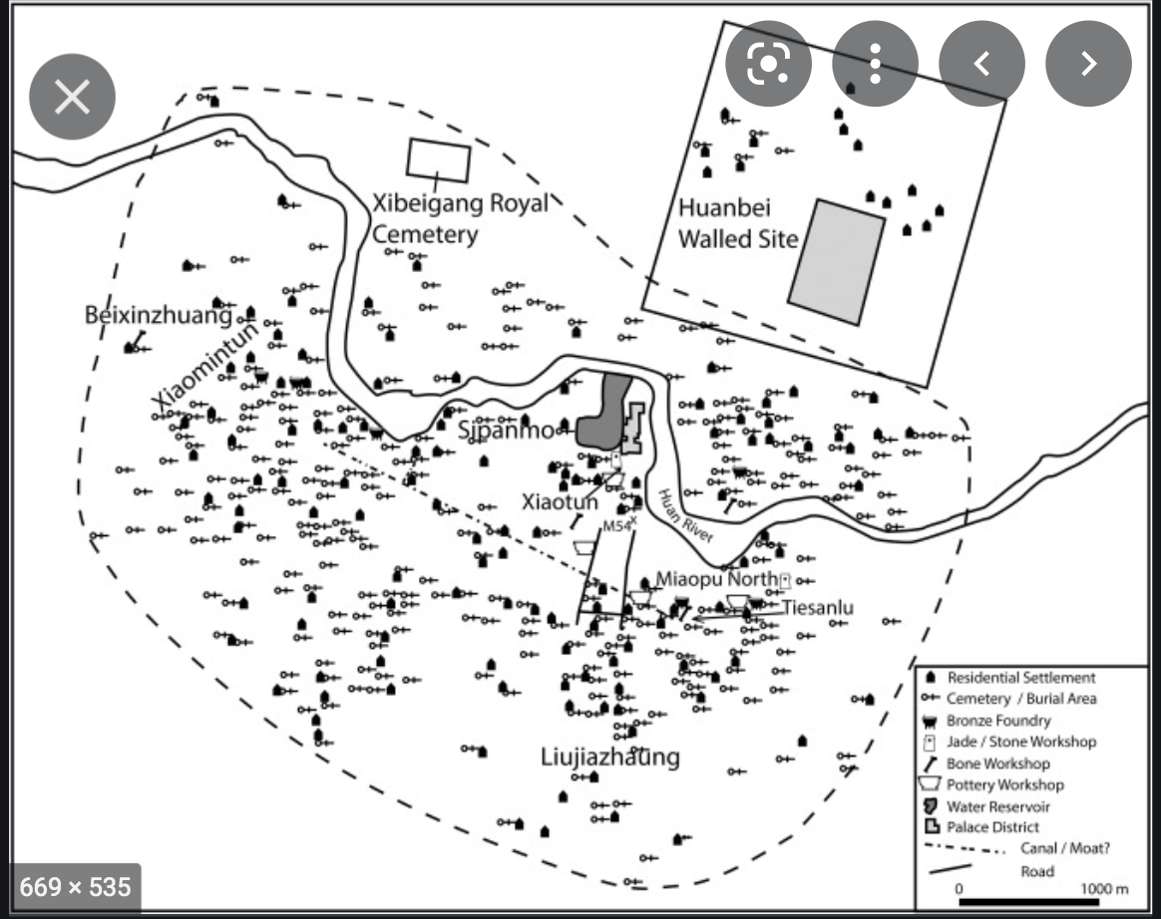

Rowan Flad, Urbanism as technology in early China, Archaeological Research in Asia Publisher: Elsevier, 2018 Archaeological Research in Asia Volume 14, June 2018, Pages 121-134, <https://www.sciencedirect.com/science/article/abs/pii/S2352226716300770>

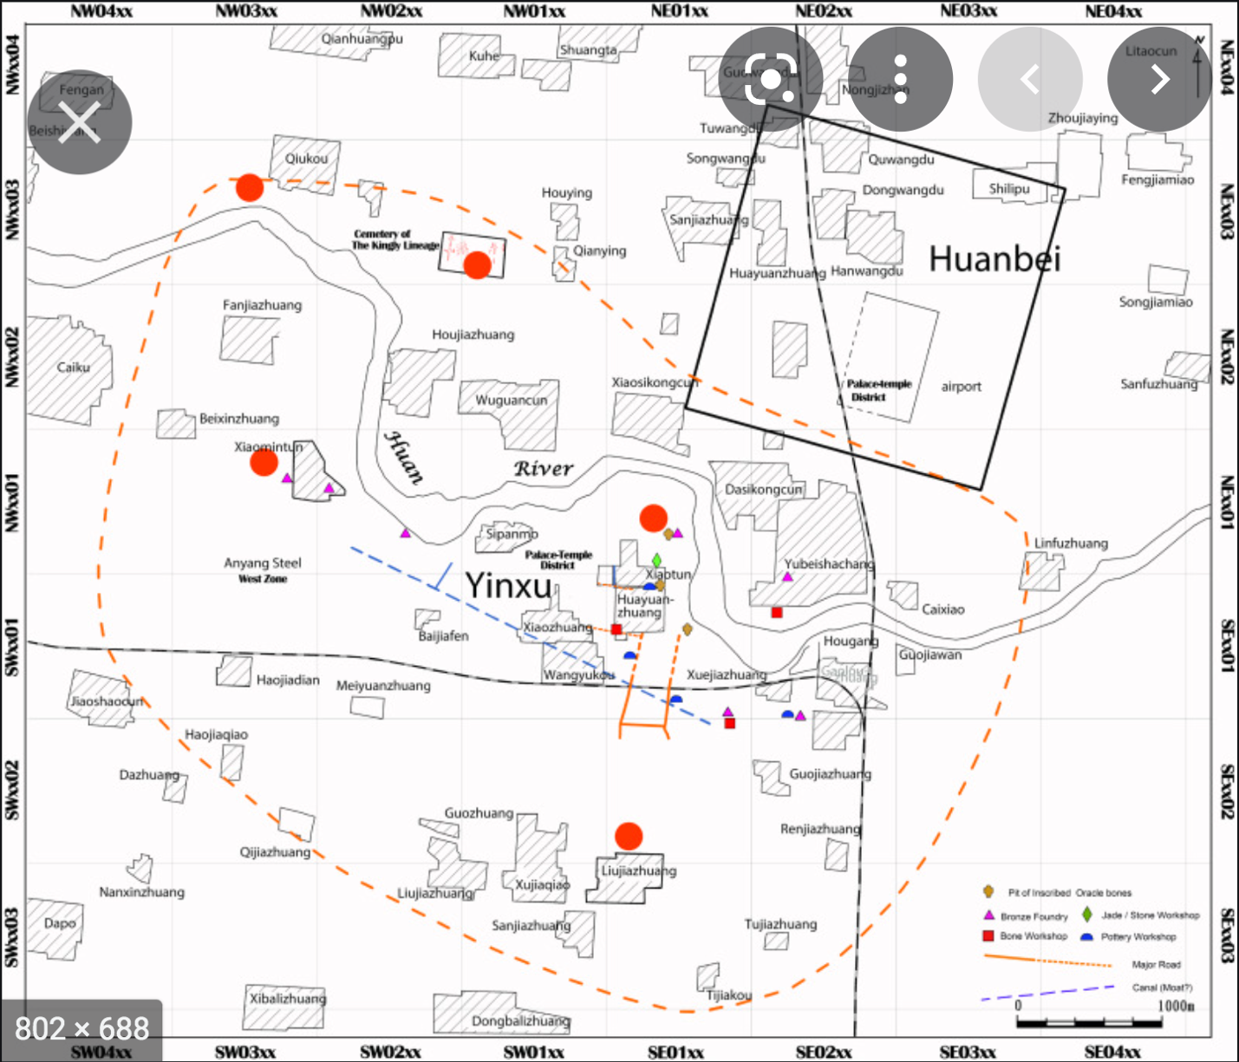

<https://www.sciencedirect.com/science/article/abs/pii/S2352226717300491>

Annihilation or decline: The fall of Anyang as an urban center

Author links open overlay panel Yung-ti(a), Lia ZhanweiYue(b), YulingHe(b)

a

East Asian Languages and Civilizations, University of Chicago, United States

b

Anyang Archaeological Team, Institute of Archaeology, Chinese Academy of Social Sciences, China

Received 20 April 2016, Revised 17 June 2017, Accepted 20 June 2017, Available online 20 September 2017.

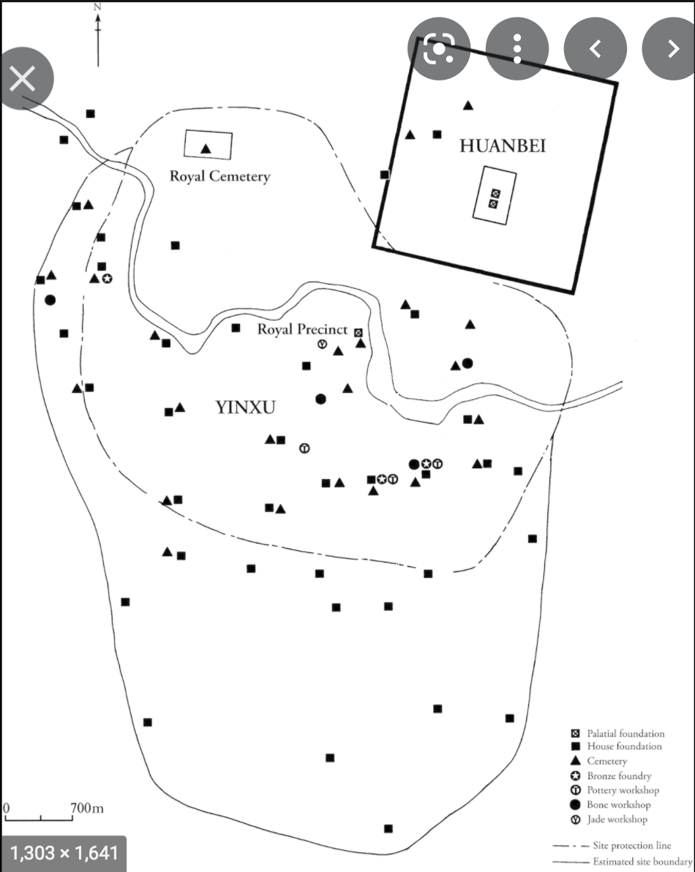

Part II - Early cities and information technologies

Published online by Cambridge University Press: 05 March 2015

Edited by

Norman Yoffee

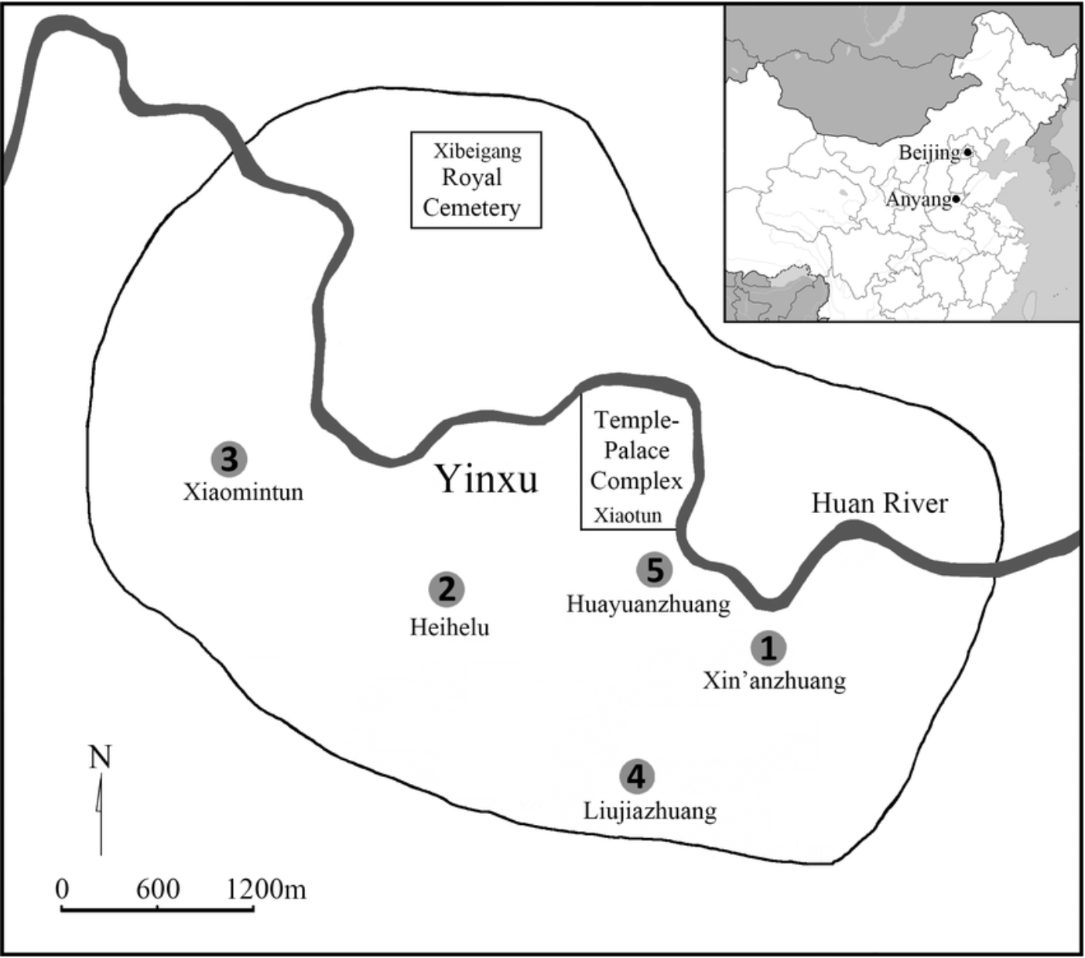

Fig 1.

Map of Yin and the locations of the sites: (1) Xin’anzhuang, (2) Xiaomintun, (3) Heihelu, (4) Liujiazhuang North, and (5) Huayuanzhuang East.

Fig 1 - Osteoarchaeological Studies of Human Systemic Stress of Early Urbanization in Late Shang at Anyang, China

1. Guo Mo-Rou 郭沫若, “甲骨文字研究-释支干”1929-8-1, p232.
2. 李大棨 (Li Daqi), 從毛筆說起 (Of Chinese Brush Pen), 石氏基金會(Stone’s Foundation Journal), No.60 Winter, 2016. <https://www.dynamicfoundation.org/article/%E5%BE%9E%E6%AF%9B%E7%AD%86%E8%AA%AA%E8%B5%B7/?lang=zh-hant> , 2022 visited. 據考古學家的說法：中國毛筆當溯源於新石器時代發掘出來的陶器，其上繪寫的圖騰及符號所用的工具就是毛筆，其年代約在五千年前。另在龜甲上發現先用毛筆預寫的底稿筆跡，不知何故漏刻成字，可從殘留的筆跡看出已有使用毛筆的事實。若屬商朝，則也有三千年左右的歷史了。   
   毛笔起源于公元前1600-1066左右, Science Museums of China <http://www.kepu.net.cn/vmuseum/civilization/printing/evolve/evl121.html> (2022visited)  
     
   The earliest brush pen (300 BC) was unearthed at ZuoJiaGongShan, ChangSha of Hunan in 1954, Hunan Archeology,   
   <http://www.hnkgs.com/show_news.aspx?id=972> or pkg20/src/HunanArcheology/ChuState_BrushPen.html
3. 董作宾 and 胡厚宣. 甲骨年表. 立中央究院史言究所刊: 乙. 商印, 1937, p.47.
4. 赵志军. “小麦传入中国的研究——植物考古资料”. in: 南方文物 3 (2015). Wheat was first found in China around 4000-4500 BC. It is about 6,000 years later than Fertile Crescent areas.
5. 2.___00_Tbl_ChineseCharactersDevolutionProcess.htm.
6. Guo Mo-Rou 郭沫若, “甲骨文字研究-释支干”1929-8-1
7. Wang Xianhua(王献华), 郭沫若《释支干》与泛巴比伦主义, 郭沫若学刊 2016-1, pp41-44
8. Adam Smith, *The Evidence for Scribal Training at Anyang*, Writing and Literacy in Early China: Studies from Columbia Early China Seminar, Editor Li Feng and David Prager Branner, 2011, University of Washington Press, p185
9. Adam Smith, *The Evidence for Scribal Training at Anyang*, Writing and Literacy in Early China: Studies from Columbia Early China Seminar, Editor: Li Feng and David Prager Branner, 2011, University of Washington Press, p185
10. /Users/weiding/Sites/weidroot/weidroot_2017-01-06/app/github/wdingbox/obilab/test1/oohtm/works1/4.___20_Tbl-book-and-gospel.htm

    file:///Users/weiding/Sites/weidroot/weidroot_2017-01-06/app/github/wdingbox/obilab/test1/oohtm/works1/5.___05_Earliest_Handbook_notes.htm
11. file:///Users/weiding/Sites/weidroot/weidroot_2017-01-06/app/github/wdingbox/obilab/test1/oohtm/works1/5.___05_Earliest_Handbook_turtle.htm
12. Stephen Chrisomalis. Numerical Notation: A comparative History. New York, NY: Cambridge University Press, 2010. p362.
13. Nagai Toshiya, Why Did Sumerians Use the Sexagesimal System? <https://www.nagaitoshiya.com/en/2013/sexagesimal/>
14. Guo Morou,
15. Minutes and seconds were but hypothetical quantities of time. According to David S. Landes, in “ Revolution in Time ” (Belknap, 1983), the Western astronomers of the 16th century began physically realizing minutes and seconds with the construction of improved clocks with minute and second hands in order to improve measurements of the sky.
16. Adam Smith, *The Evidence for Scribal Training at Anyang*, Writing and Literacy in Early China: Studies from Columbia Early China Seminar, Editor Li Feng and David Prager Branner, 2011, University of Washington Press, p185
17. K.C. Chang, Continuity and Rupture: Ancient China and the Rise of Civilizations, Manuscript being prepared for publication. https://min.news/en/culture/59a6f27153177a16b35cd6a71b0ac432.html
18. <http://ntupoli.s3.amazonaws.com/wp-content/uploads/2011/03/7.%E4%B8%AD%E5%9C%8B%E5%8F%A4%E4%BB%A3%E7%9A%84%E5%B7%AB.pdf>
19. THE WORKS OF SAINT AUGUSTINE:A Translation for the 21st Century. New City Press. 2005. p17. <https://wesleyscholar.com/wp-content/uploads/2019/04/Augustine-On-Christian-Belief.pdf>
20. Rowan Flad, Urbanism as technology in early China, Archaeological Research in Asia Publisher: Elsevier, 2018 Archaeological Research in Asia Volume 14, June 2018, Pages 121-134, https://www.sciencedirect.com/science/article/abs/pii/S2352226716300770
21. Paul R. Goldin, and University of Pennsylvania. “Some Shang Antecedents of Later Chinese Ideology and Culture.” *Journal of the American Oriental Society*, vol. 137, no. 1, American Oriental Society, 2017, pp. 121–27, https://doi.org/10.7817/jameroriesoci.137.1.0121.
22. Paul R. Goldin, and University of Pennsylvania. “Some Shang Antecedents of Later Chinese Ideology and Culture.” *Journal of the American Oriental Society*, vol. 137, no. 1, American Oriental Society, 2017, pp. 121–27, https://doi.org/10.7817/jameroriesoci.137.1.0121.